**PROJECTS**

**1.Deploying website on AWS EC2 instance.**

**Create Virtual private cloud (VPC)**

**Steps**

**1.**In AWS console, search VPC.

**2**.In VPC dashboard,select your **[Your VPCs](https://ap-northeast-2.console.aws.amazon.com/vpcconsole/home?region=ap-northeast-2" \l "vpcs:).**

**3.**Click create VPC button

**4.**Provide VPC name as yathish-vpc and IPv4 CIDR as 10.0.0.0/16

**5.**Then click create VPC button.

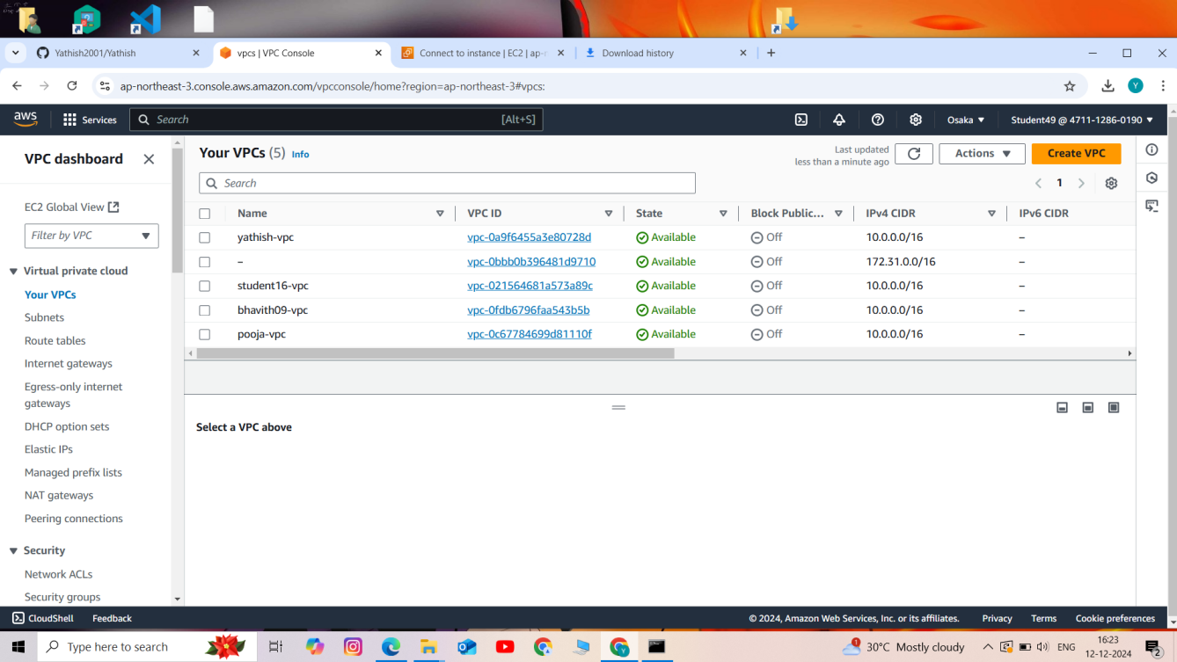

**Create Internet Gateway(IGW)**

**Steps**

**1.** In VPC dashboard, select **Internet gateways**.

**2.** Click create internet gateways button.

**3.** Provide internet gateway name as yathish-igw.

**4.** Click create internet gateway button.

**5**. Attach it to VPC.

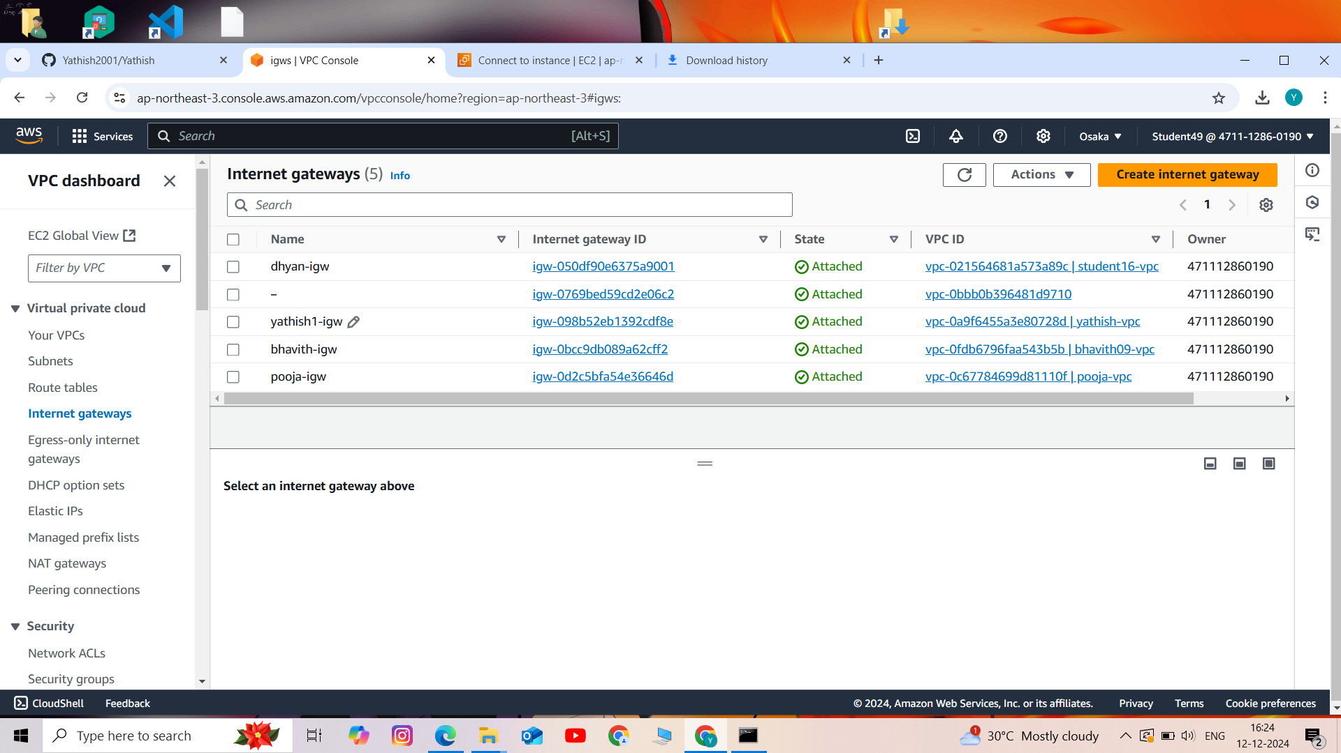

**Create Public subnet**

**Steps:**

**1.** In VPC dashboard, select **Subnets**.

**2.** Click create subnet button.

**3.** Select the appropriate VPC ID.

**4.** Provide Subnet name as public-subnet1 and select the appropriate avalaiblity zone and provide the IPv4 subnet CIDR block as 10.0.1.0/24.

**5.**Create another subnet by clicking add new subnet by providing public-subnet2and select the appropriate avalaiblity zone and provide the IPv4 subnet CIDR block as 10.0.2.0/24.

**6.**Click create subnet button

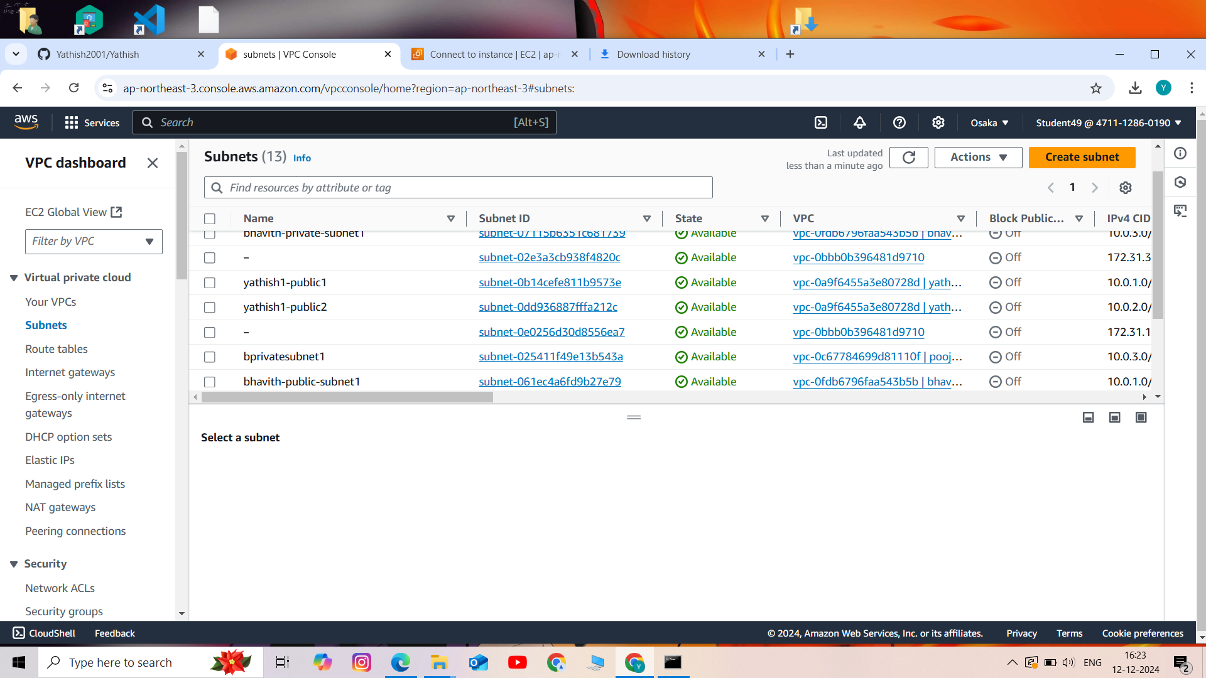



**Create Route tables**

**Steps**

**1.** In VPC dashboard, select **Route tables**.

**2.** Click create route table button.

**3.** In Route table settings,provide name as public-RT and select the VPC created and then click .

**4**. Under Routes ,click edit route.

**5.** Select Internet gateway and select the gateway and save the changes.

**6**.Under Subnet Association, select edit subnet Association and check the subnets creates and save changed.

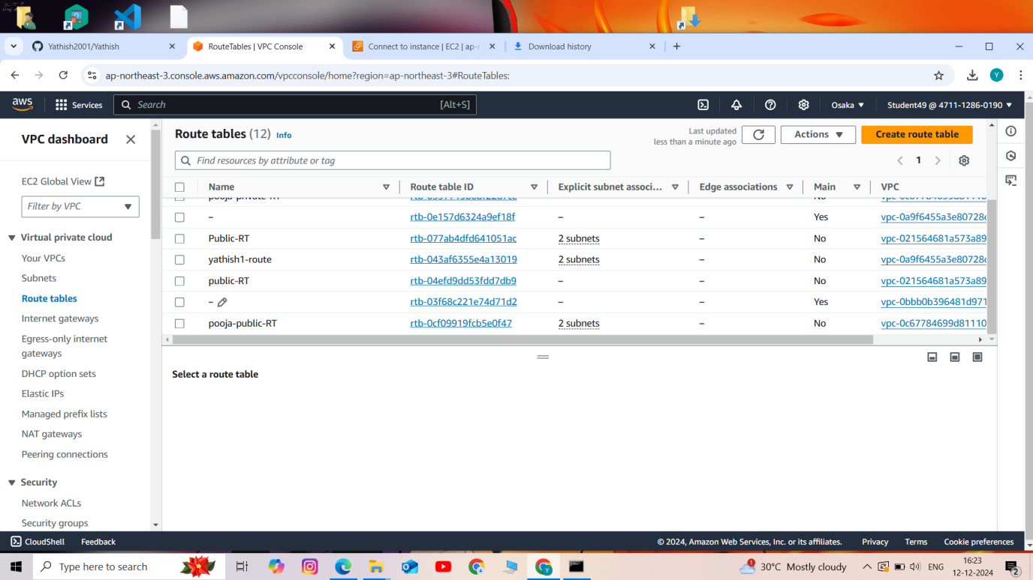

**Connection to instance**

**Steps**

**1.**Search for EC2 and under the dashboard select instances.

**2**.Click the Launch instance button.

**3**.Provide the name asyathish-server, instance type as t2.micro ,create keypair as mca-keypair

**4**. edit the network setting by selecting VPC and enable as Auto-assign public IP.

**5**.Provide the security group name asyathish-server-SG and add group rule.

**6**.Launch the instance.

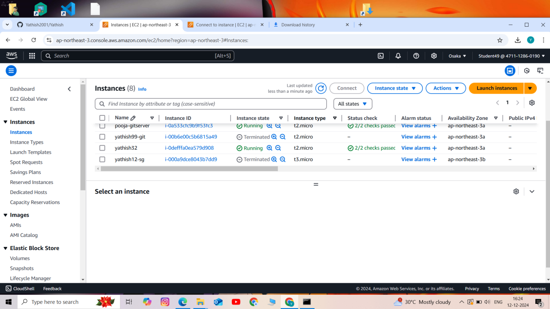

Open the command prompt and provide the following commands

**1.** cd downloads

**2**. ssh -i "yathish-keypair.pem" [ec2-user@18.230.148.85](mailto:ec2-user@18.230.148.85)

**3**. sudo su

**4.** cd

**5.** yum install httpd –y

**6.** cd /var/www/html

**7.** vi index.html

Provide the appropriate code

**8.** cat index.html

**9.** systemctl start httpd

**10.** systemctl enable httpd

**11**. systemctl status httpd

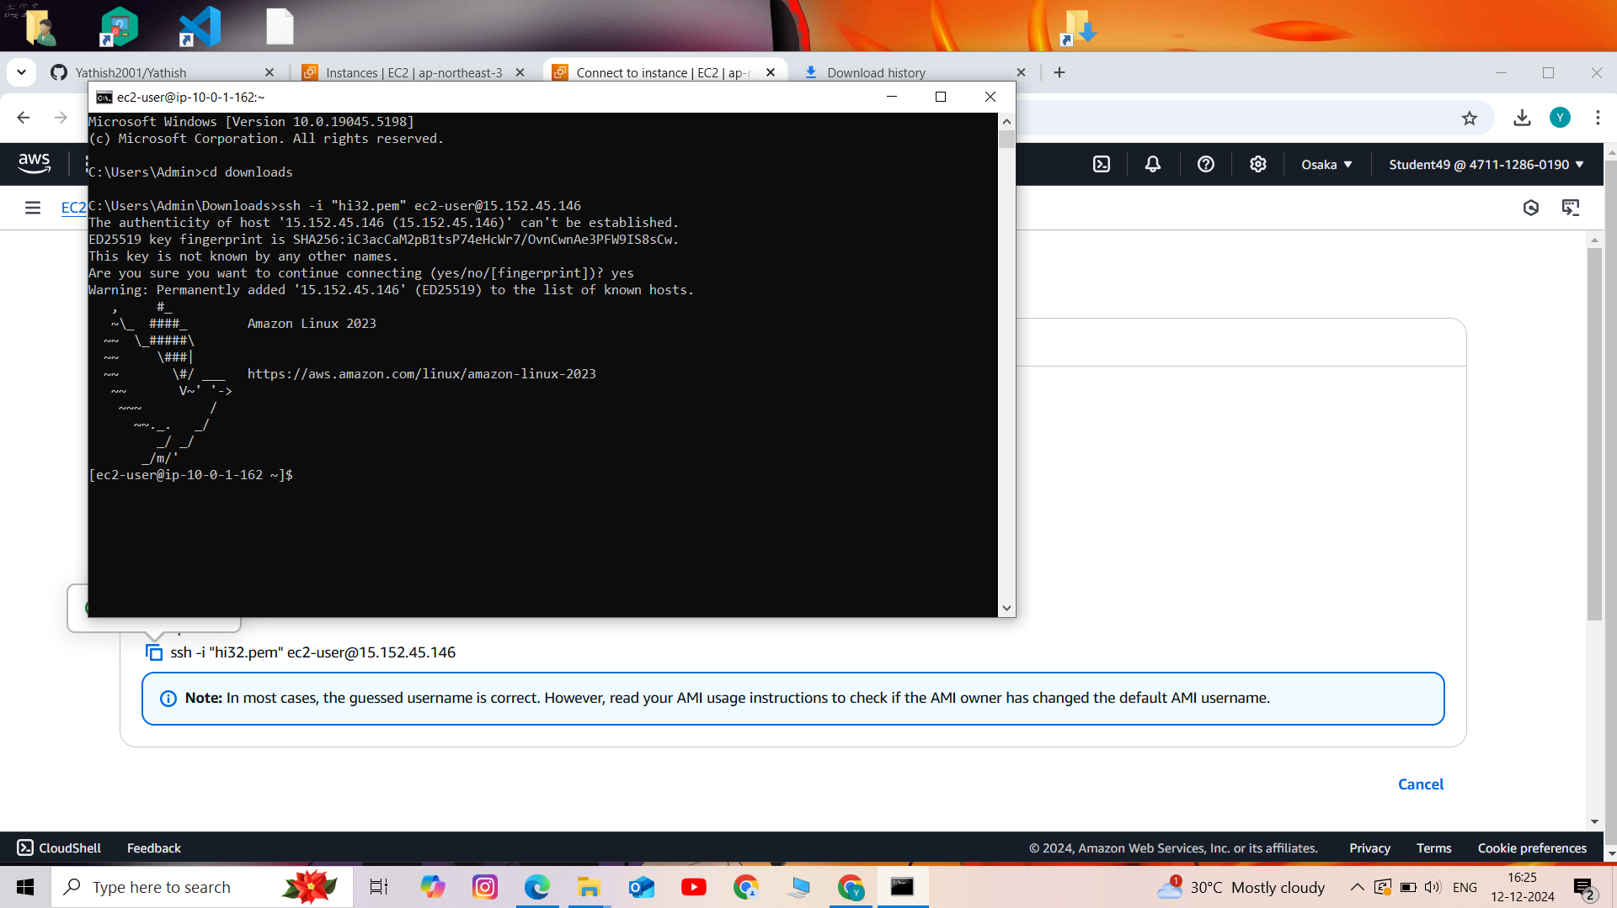



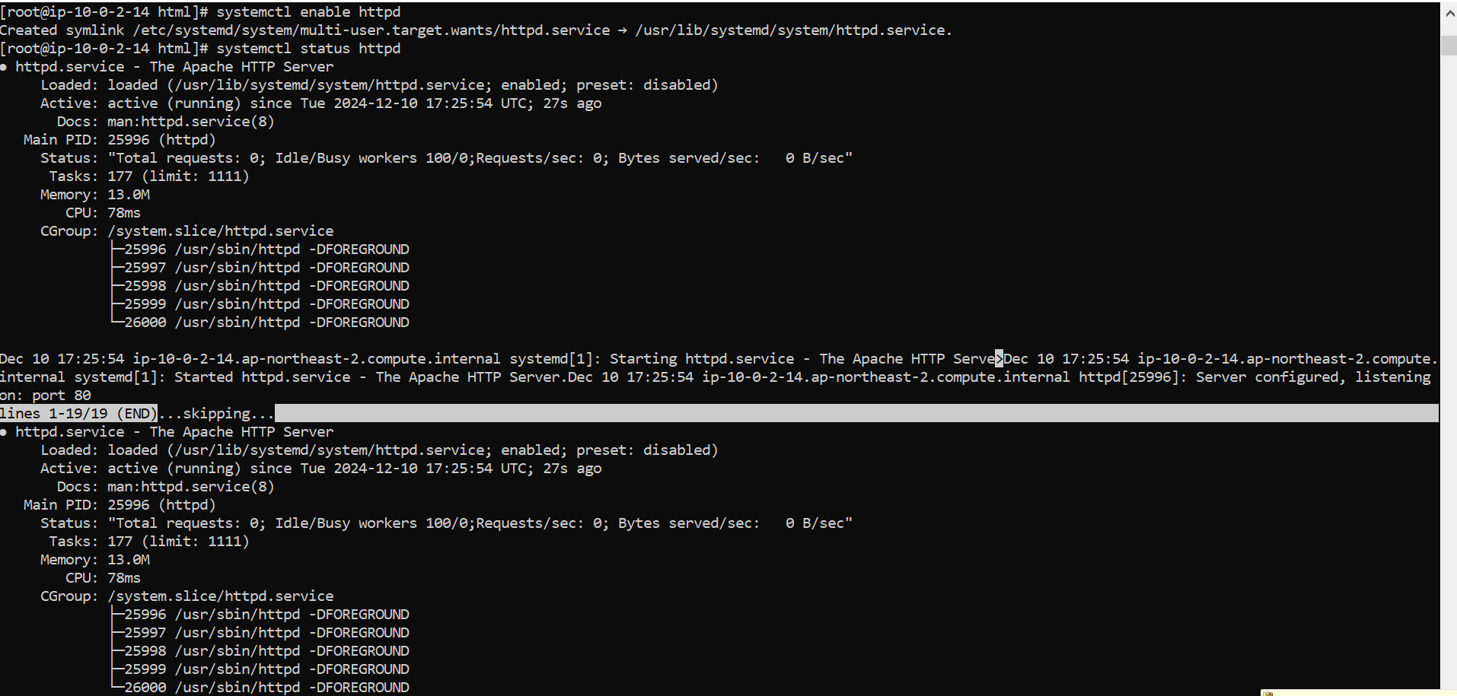

**Final Result**

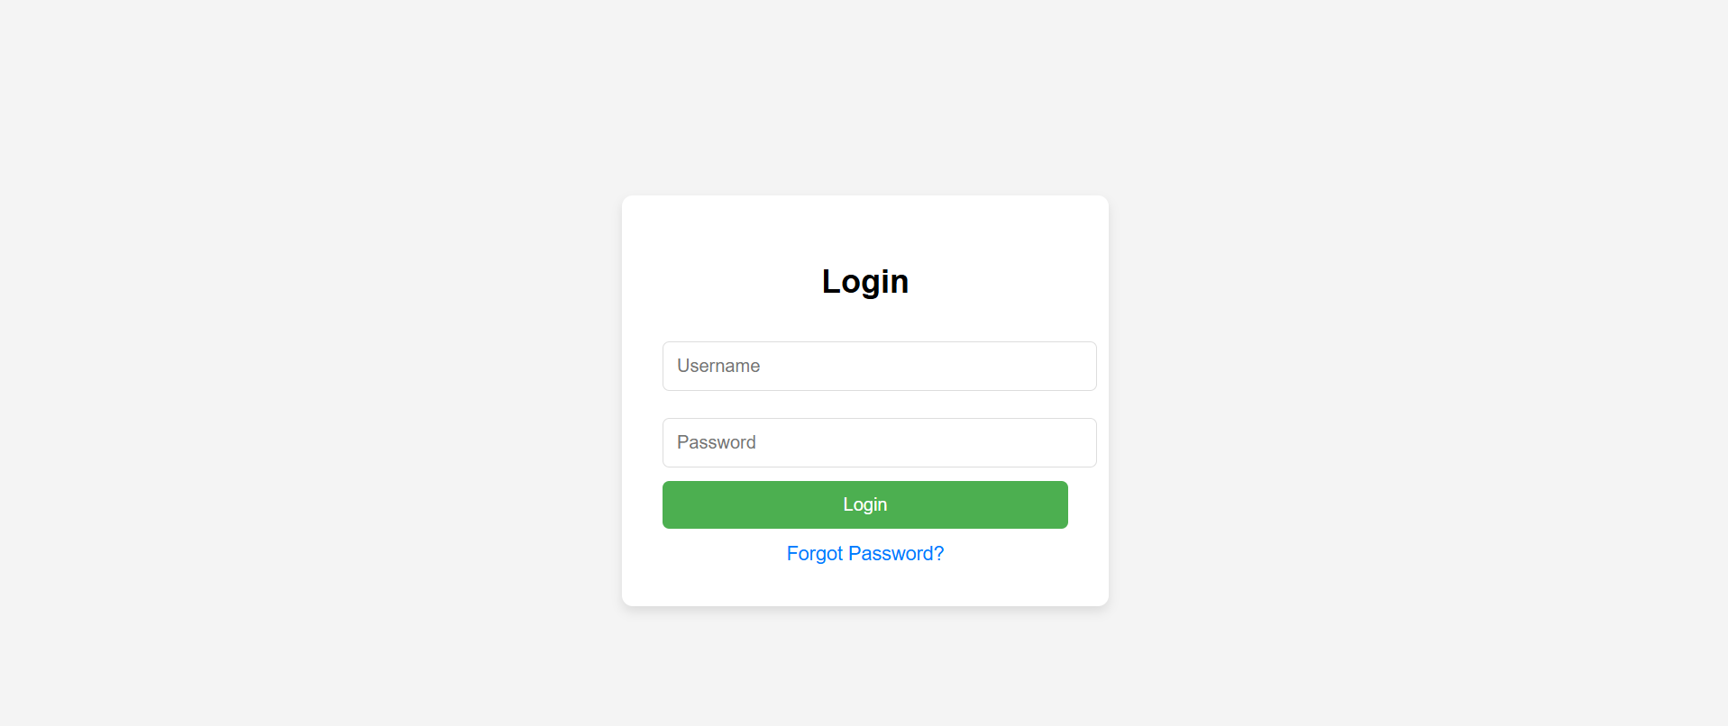

**2.How to create new instance using Amazon Machine Images.**

**Creating image**

**Steps**

**1.** Under the EC2 dashboard, select instances

**2.** Check the *yathish-server*. Under **Actions** drop down button select Images and templets and then select create image.

**3.** Provide the image name and description as *yathish-backup*.

**4.** Click the create inage button.

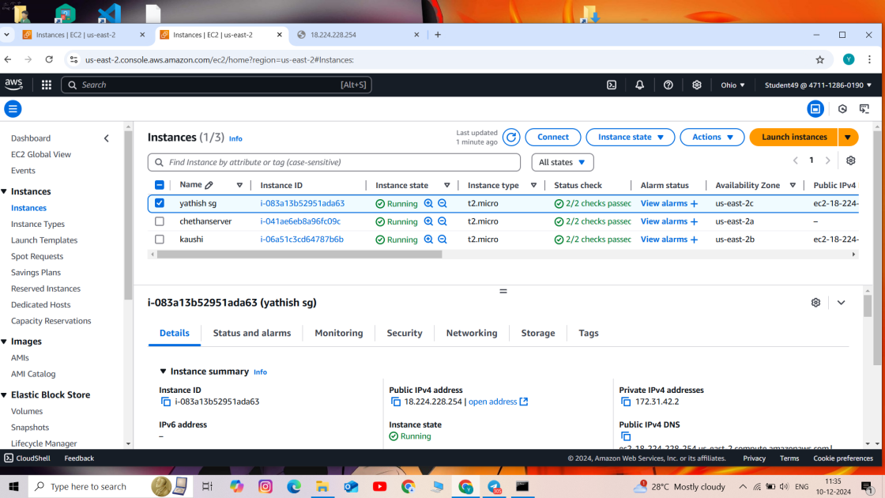

Image summary

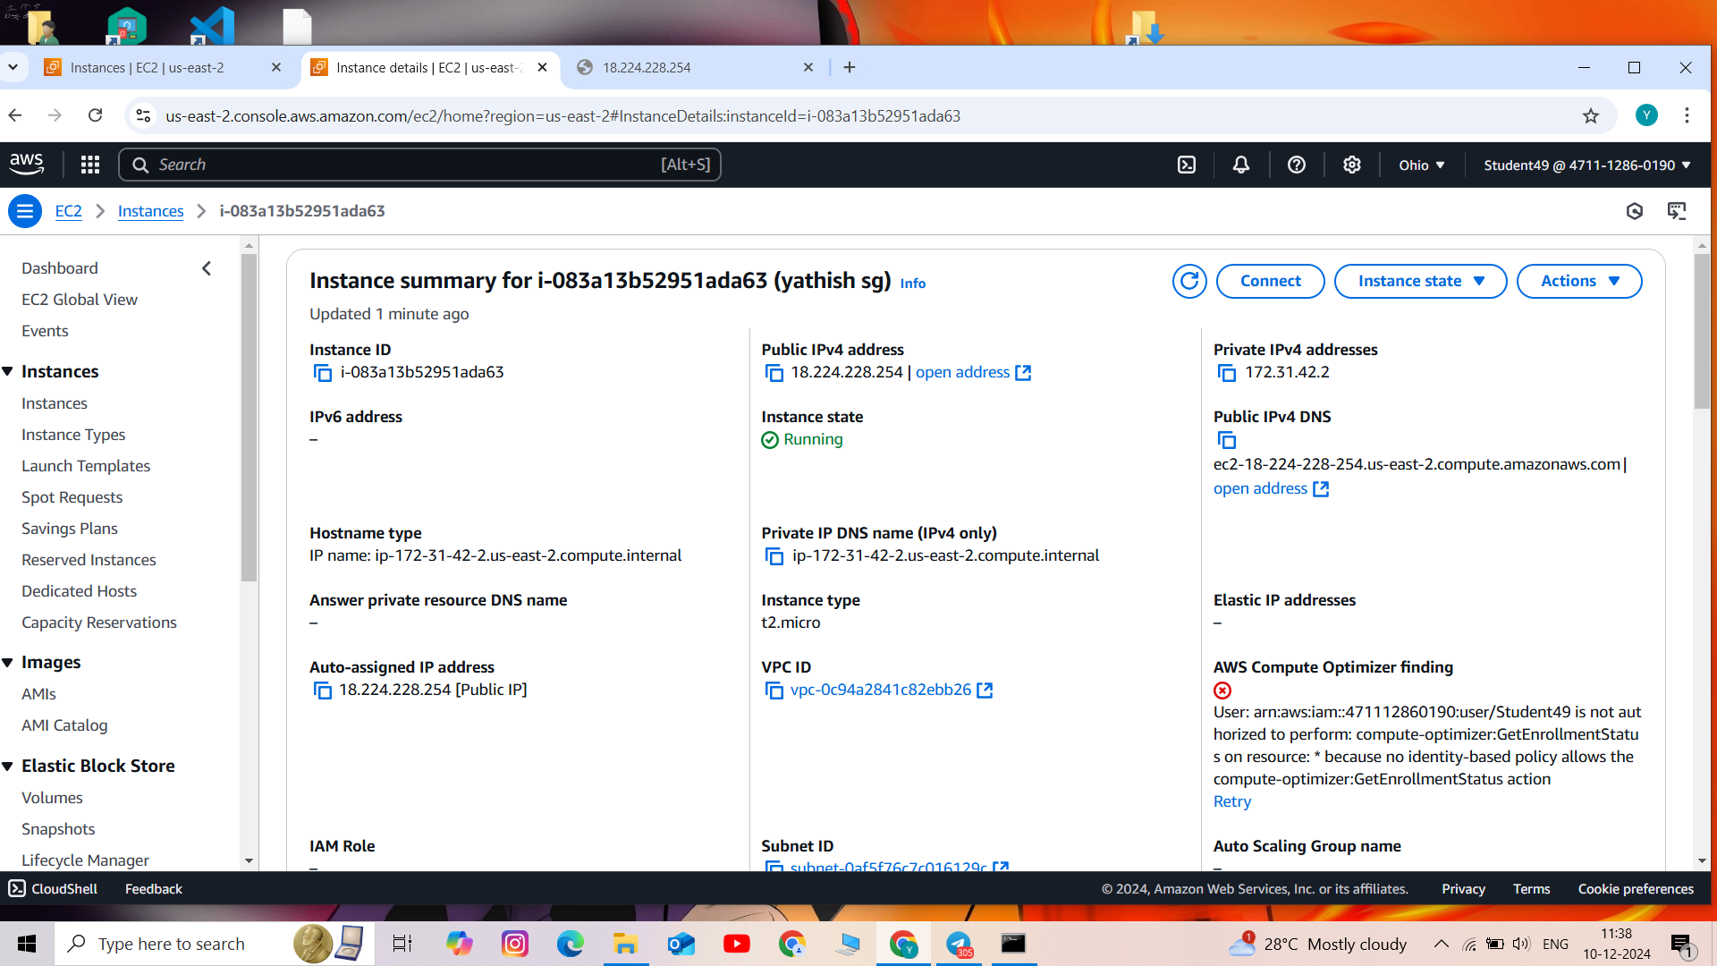

**Create Instance**

**Steps**

**1.** In the EC2 dashboard, select AMI under **Images**

**2.** Check the *yathish-backup,* click the Launch instance from AMI.

**3.** Provide the name as yathish-backup-server.

**4.** Provide the instance type as t2.micro and provide the VPC created.

**5.** Under network setting enable auto assign IP- address and select the existing security group.

**6.** Launch the activity.

**7.** Copy the Private IPv4 addresses from the instance summary and paste it in the browser.

**Instance summary**



**Final Result**



**3.How to connect private server to internet using NAT gateway(Jump server/bastion host)**

**Create Subnets**

**Steps**

**1.** In the VPC dashboard, select **Subnets**.

**2.** Click the create subnet button to create 2 public and 2 private subnets.

**3.** Select the VPC created.

**4.** Providewith the subnet name, availability zone and IPv4 subnet CIDR block for both private and public subnets.

**Private subnet1**

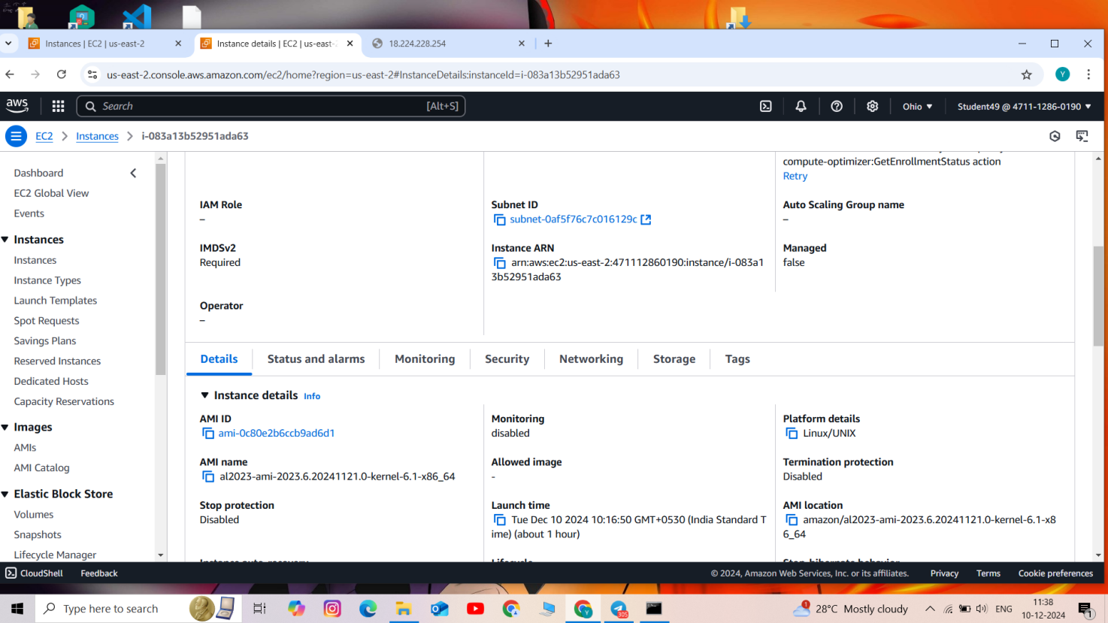

**Private subnet2**



**Public subnet1**

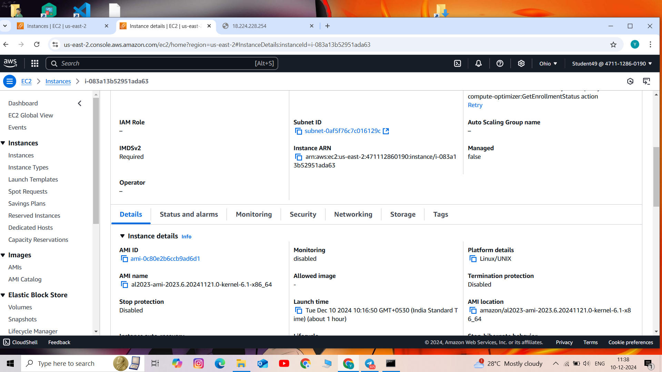

**Public subnet2**

**Create Route Table**

**Steps**

**1.** In the VPC dashboard, select **Route Table**.

**2**. Click the create route table button.

**3.** Provide the name asyathish-private-RT and the created VPC.

**4.** Under the Subnet Association, click Edit subnet association.

**5.** Check the privatesubnets and save association.



**Create NAT gateway**

**Steps**

**1.** In the VPC dashboard, select **NAT Gateways**.

**2.** Click the create NAT Gateway.

**3**. Provide the name as yathish-natgateway and select the created public subnet and the allocate Elastic IP allocation ID.

**4.** In the route table check the private-RT and provide the target as NAT gateway.



**Create public server**

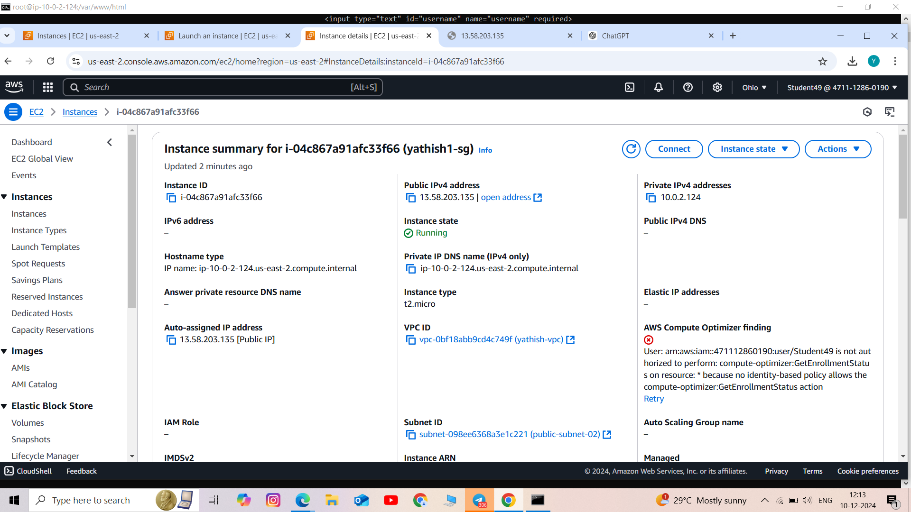

**Create Public server**



**Create Private server**

**Steps**

**1.** In EC2 dashboard**,** select instance and click Launch instances.

**2.** Provide the name as yathish-private-server and create a private keypair.

**3.** Select the appropriate VPC and provide the security group as yathish-private-server-SG.

**4.** Launch the instance.

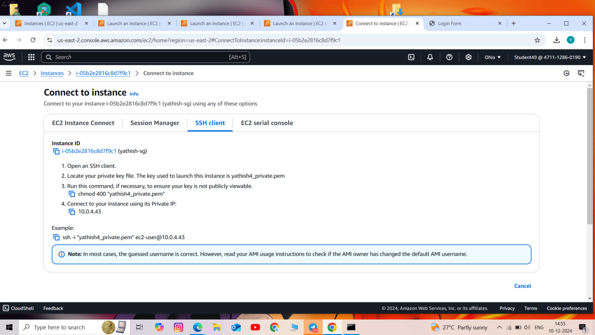

**Final result**

Open the command prompt and provide the following commands

**1.** cd downloads

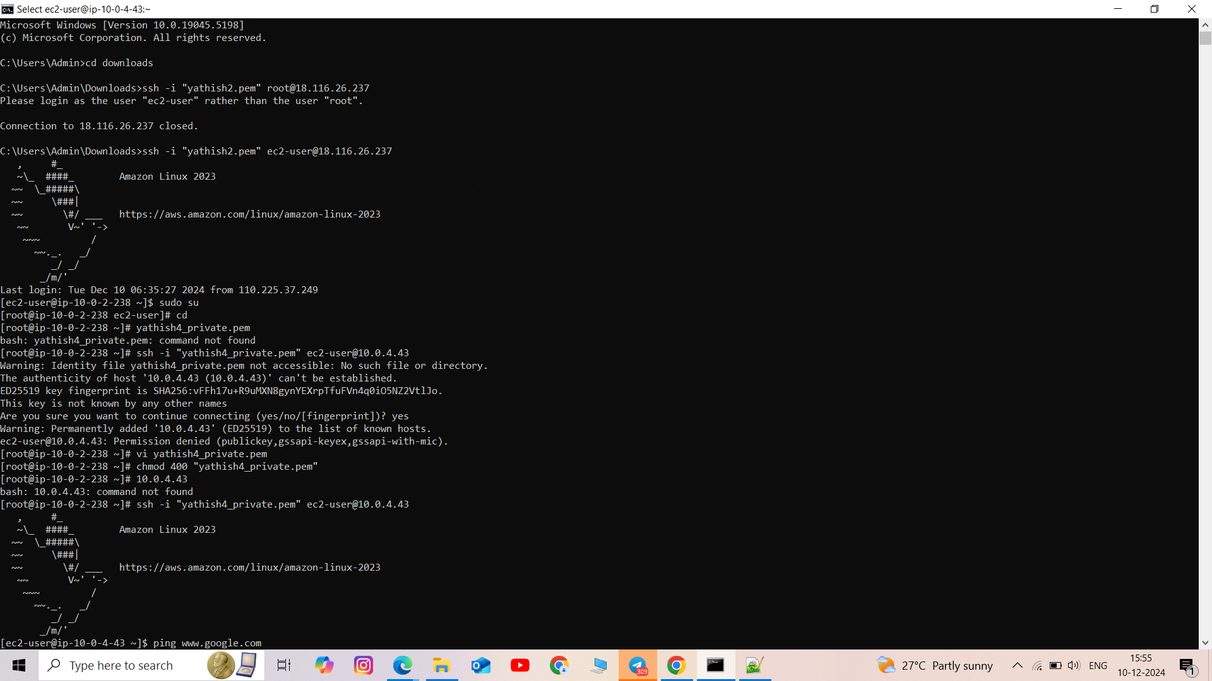

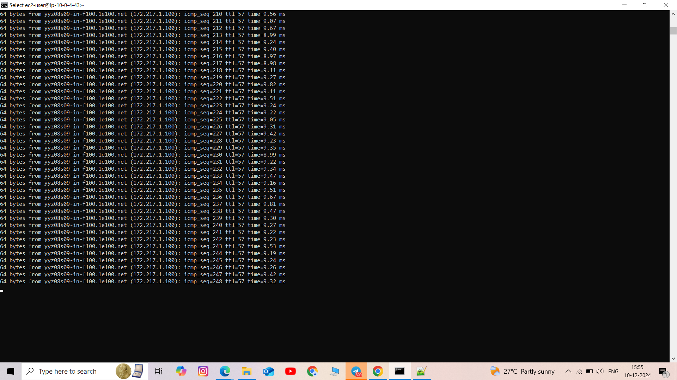

**4. Hosting a static website using S3 bucket.**

**Create S3 bucket**

**Steps**

**1** .In AWS console, search for S3 bucket.

**2.** In S3 dashboard, under [General purpose buckets](https://us-east-1.console.aws.amazon.com/s3/buckets?region=us-east-1&bucketType=general) click create bucket button.

**3.** Provide bucket type as General purpose and name as sneha36.

**4.** Enable the bucket key.

**5**.Click the create bucket.

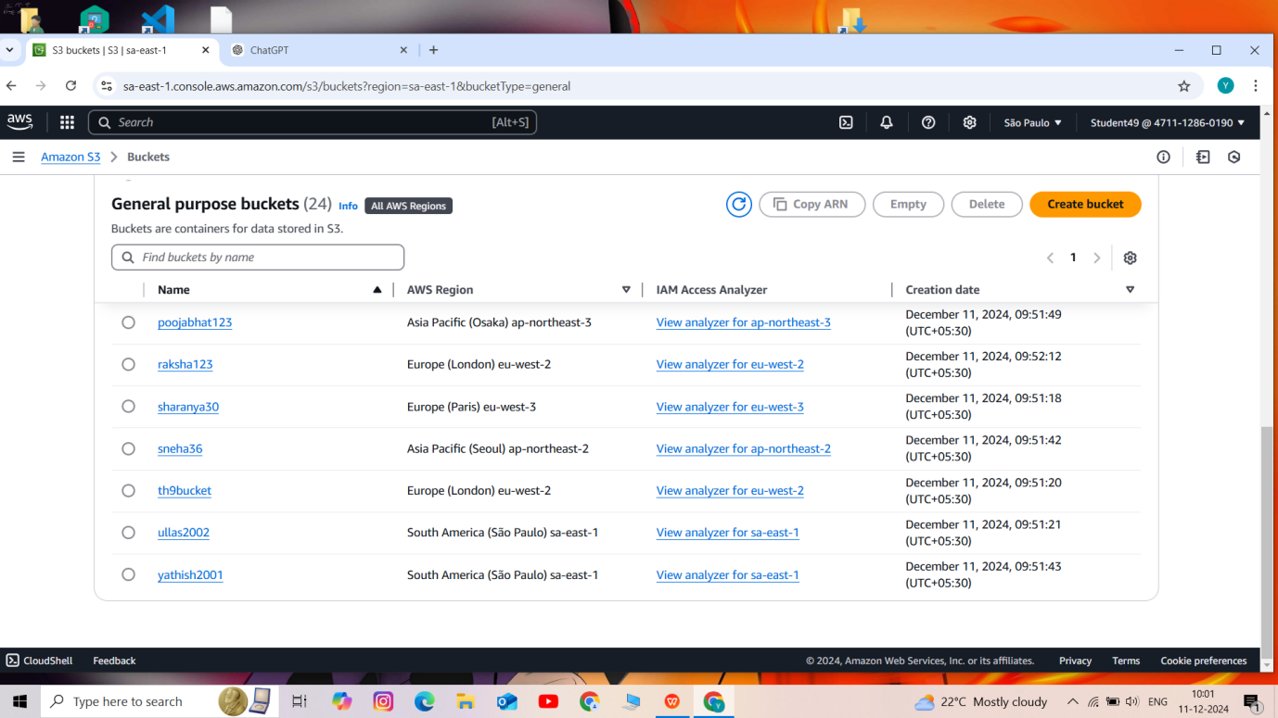

**Upload file**

**Steps**

**1.** Click on the bucket that has been create

**2.** Click on the upload button.

**3.** Choose the file to upload and click the upload button.

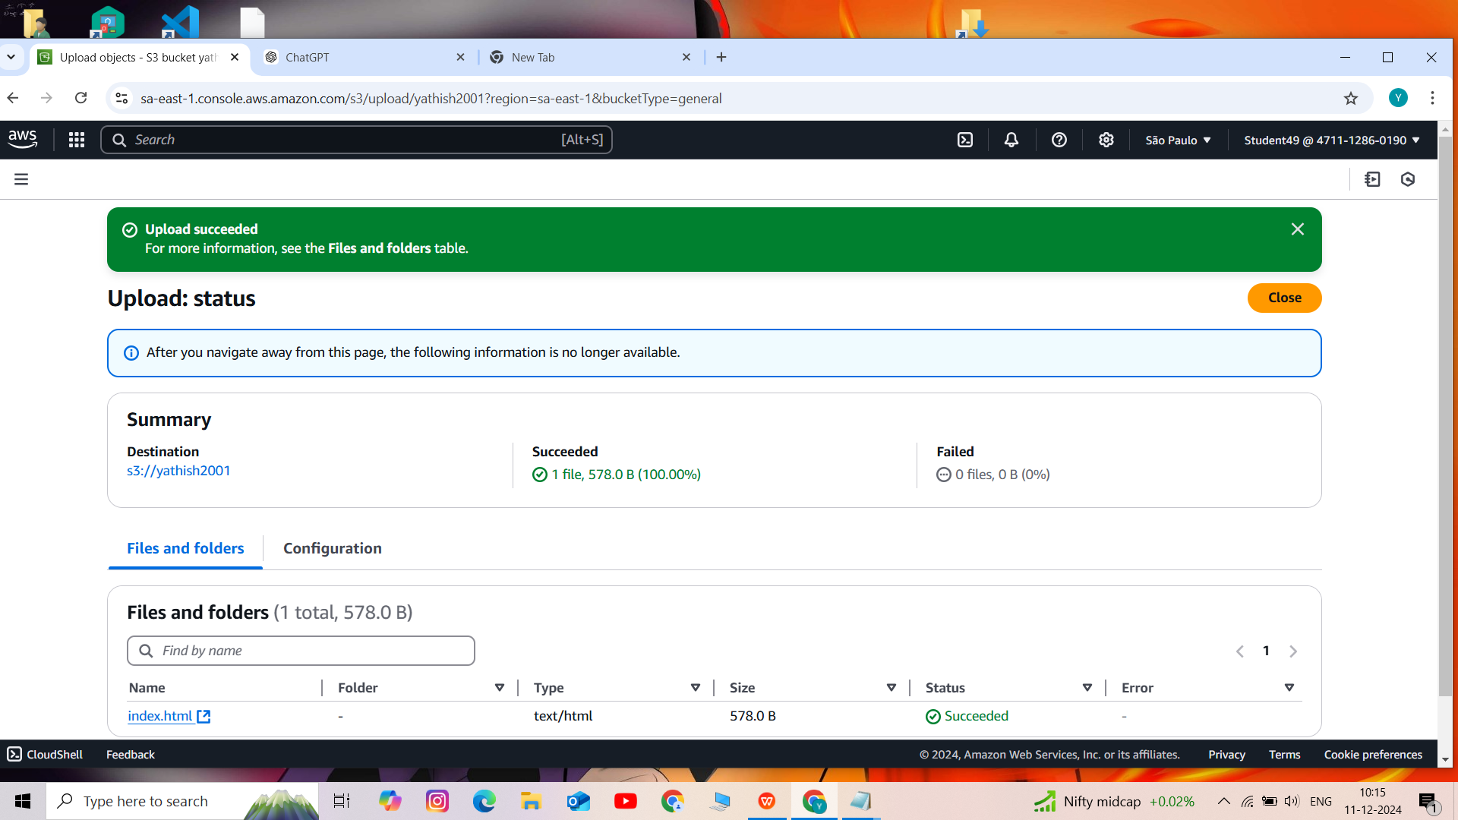

**Static website hosting**

**Steps**

**1.** Click on the bucket that has been create.

**2.** Under the properties,click edit static webste hosting.

**3.** Provide the index document as index.html

**4.** Click the save changes.

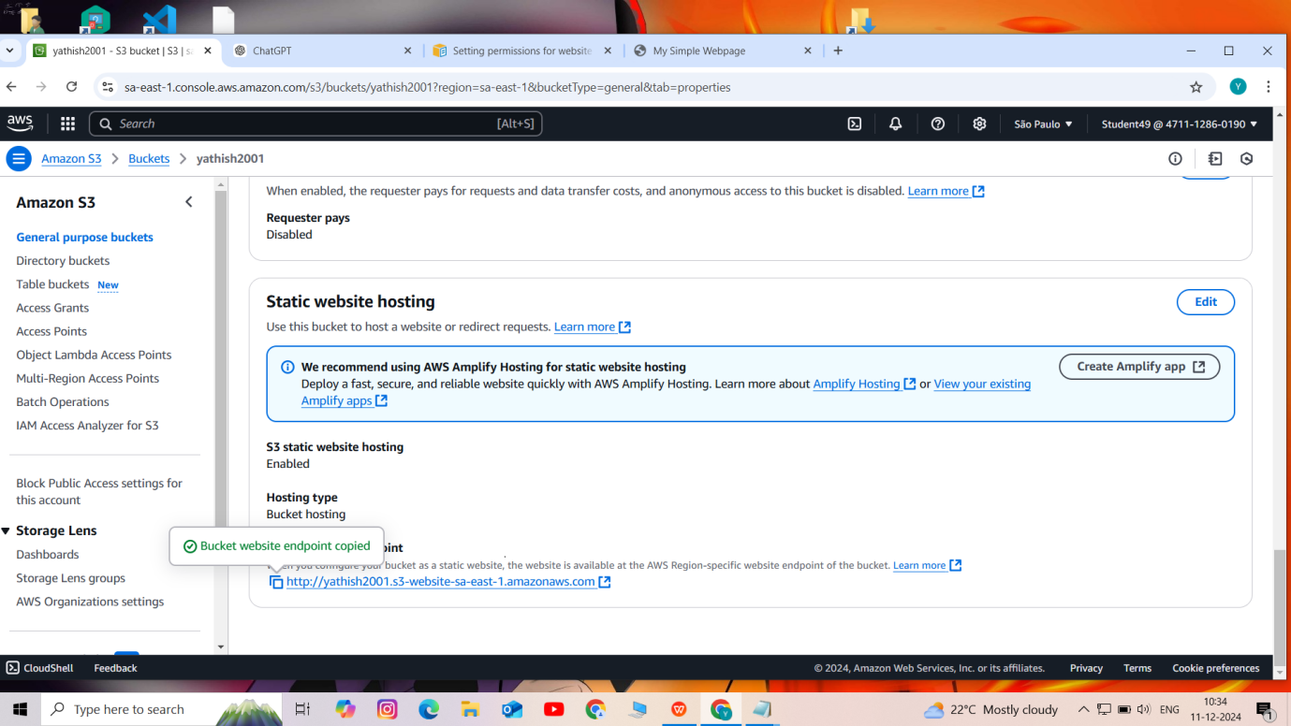

**Block public access**

**Steps**

**1.** Under permission, click Edit Block public access.

**2.** Uncheck Block of public access and confirm



**Bucket policy**

**Steps**

**1.** Under permission, click Edit Bucket policy.

**2.** In chrome, search Bucket policy for static website and copy the code of step 2.

**3.** Paste in bucket policy and provide the bucket name as sneha36.

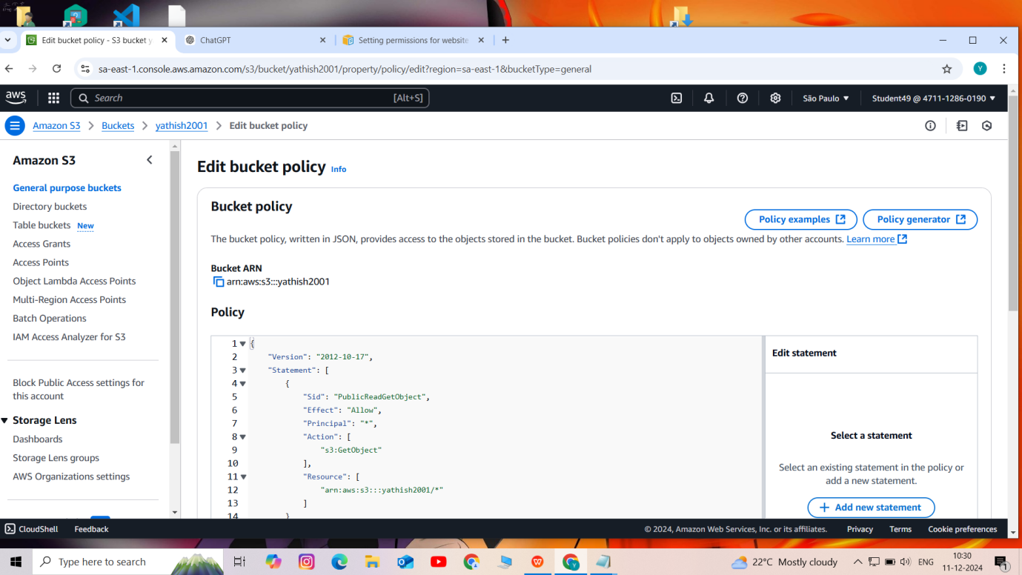

**Final Result**

Under properties copy the url of static website hosting

